1. **Relative vs absolute positioning in css:**

An element in an absolute position is positioned relatively to the nearest positioned parent (instead of to the viewport, like fixed). In the case where has no positioned ancestors/parent, it moves along with page scrolling while using the document body. is the total of all existence .An element in a relative position; is positioned relative to its normal position. It is always in proportion to a whole. Relative is dependent while absolute is independent.

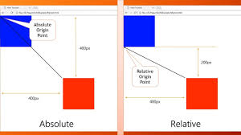

1. **css box sizing and more precisely margin vs padding:**

The box-sizing CSS property sets how the total width and height of an element is calculated. Padding is the space between an element and the content inside it and A margin is the space around an element. In creating the gap, the padding is placed inside the border of an element However margin pushes adjacent elements away.

